Aboriginal and Torres Strait Islander Health Practice registrant data: December 2014
Published March 2015

Introduction
The functions of the Aboriginal and Torres Strait Islander Health Practice Board of Australia include:
- registering the Aboriginal and Torres Strait Health Islander health practitioners and students
- developing standards, codes and guidelines for the Aboriginal and Torres Strait Islander health practice profession
- handling notifications, complaints, investigations and disciplinary hearings, and
approving accreditation standards and accredited courses of study.
The Board’s functions are supported by the Australian Health Practitioner Regulation Agency (AHPRA). For information about legislation governing our operations see AHPRA's Legislation & Publications at www.ahpra.gov.au/Publications
The Board has analysed its registration data and produced a number of statistical breakdowns about registrants to share with the profession and community. The Board shares these breakdowns regularly.
For more information on Aboriginal and Torres Strait Islander Health Practitioners registration, please see the Board’s website: www.atsihealthpracticeboard.gov.au/Registration

Contents
ATSI health practitioners – registration type by principal place of practice 3
ATSI health practitioners – percentage by principal place of practice 3
ATSI health practitioners – registration type by age group 4
ATSI health practitioners – by age group 5
ATSI health practitioners – registration type by gender 6
ATSI health practitioners – percentage by gender 6

ATSI health practitioners – registration type by principal place of practice
ATSI health practitioners | Principal place of practice
Registration type | ACT | NSW | NT | QLD | SA | TAS | VIC | WA | No PPP | Total
General | 4 | 44 | 228 | 39 | 17 | 1 | 9 | 33 | 1 | 376
Non-practising
Total | 4 | 44 | 228 | 39 | 17 | 1 | 9 | 33 | 1 | 376
ATSI health practitioners – percentage by principal place of practice
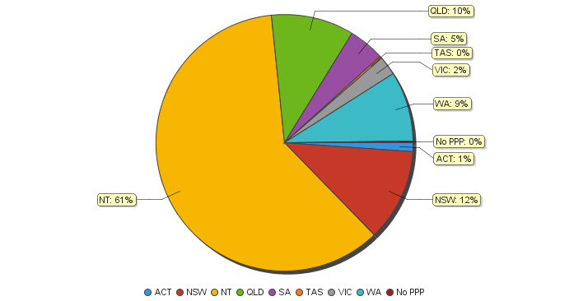

ATSI health practitioners – registration type by age group
ATSI health practitioner | Registration type
Age group | General | Non-practising | Total
U - 25 | 10 |  | 10
25 - 29 | 22 |  | 22
30 - 34 | 37 |  | 37
35 - 39 | 44 |  | 44
40 - 44 | 68 |  | 68
45 - 49 | 61 |  | 61
50 - 54 | 55 |  | 55
55 - 59 | 44 |  | 44
60 - 64 | 24 |  | 24
65 - 69 | 8 |  | 8
70 - 74 | 2 |  | 2
75 - 79 | 1 |  | 1
80+
Total | 376 |  | 376

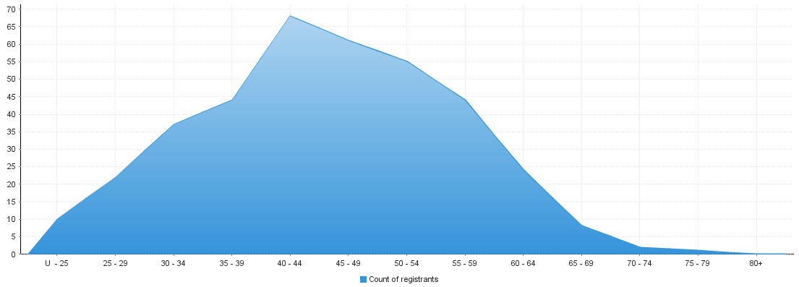
ATSI health practitioners – by age group
Age group | U - 25 | 25 - 29 | 30 - 34 | 35 - 39 | 40 - 44 | 45 - 49 | 50 - 54 | 55 - 59 | 60 - 64 | 65 - 69 | 70 - 74 | 75 - 79 | 80+
Count of registrants | 10 | 22 | 37 | 44 | 68 | 61 | 55 | 44 | 24 | 8 | 2 | 1

ATSI health practitioners – registration type by gender
Principal place of practice
Gender | Registration type |  | ACT | NSW | NT | QLD | SA | TAS | VIC | WA | No PPP | Total
Female | General |  | 2 | 34 | 166 | 29 | 13 | 1 | 8 | 27 | 1 | 281
 | Non-practising
Sub Total |  |  | 2 | 34 | 166 | 29 | 13 | 1 | 8 | 27 | 1 | 281
Male | General |  | 2 | 10 | 62 | 10 | 4 |  | 1 | 6 |  | 95
 | Non-practising
Sub Total |  |  | 2 | 10 | 62 | 10 | 4 |  | 1 | 6 |  | 95
Total |  |  | 4 | 44 | 228 | 39 | 17 | 1 | 9 | 33 | 1 | 376

ATSI health practitioners – percentage by gender
ATSI health practitioners | Principal place of practice
Gender | ACT | NSW | NT | QLD | SA | TAS | VIC | WA | No PPP | Total
Female | 50.00% | 77.27% | 72.81% | 74.36% | 76.47% | 100.00% | 88.89% | 81.82% | 100.00% | 74.73%
Male | 50.00% | 22.73% | 27.19% | 25.64% | 23.53% | 0.00% | 11.11% | 18.18% | 0.00% | 25.27%

