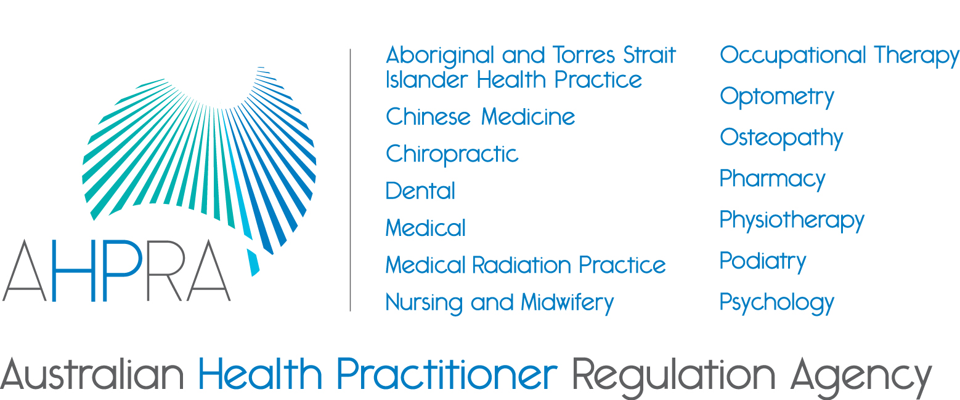

Consultation paper
29 August 2018

Draft revised accreditation standards for Aboriginal and Torres Strait Islander Health Practice, Chinese Medicine and Medical Radiation Practice
The Aboriginal and Torres Strait Islander Health Practice, Chinese Medicine and Medical Radiation Practice Accreditation Committees (Accreditation Committees) are undertaking a joint review of their accreditation standards published in 2013. Accreditation standards are used to assess whether a program of study (and the education provider delivering the program) provide graduates with the knowledge, skills and professional attributes necessary to practise the profession competently and safely in Australia.
Preliminary consultation
From late-June to early-August 2018 the Accreditation Committees undertook a targeted preliminary consultation to key stakeholders. Preliminary consultation enabled the Accreditation Committees to test proposals and refine them before proceeding to public consultation. It also provided an opportunity for feedback to improve the clarity of the consultation documents.
A range of stakeholders from across the three professions submitted written responses, including professional associations, jurisdictions (Commonwealth and state/territory health departments), individuals and the Health Professions Accreditation Collaborative Forum.
The Accreditation Committees are now releasing this consultation paper for public feedback.
Providing feedback
The Accreditation Committees are seeking to consult on their draft revised accreditation standards (attached). In addition to general feedback, they are interested in stakeholders’ feedback on specific questions about the revised accreditation standards.
Feedback can be provided by sending a written submission by email, to accreditationstandards.review@ahpra.gov.au.
This should be provided by close of business on 15 October 2018
Submissions for website publication should be sent in Word format or equivalent.
Publication of submissions
The Accreditation Committees and AHPRA publish submissions at their discretion.
We generally publish submissions on our websites to encourage discussion and inform the community and stakeholders. Please advise us if you do not want your submission published.
We will not place on our websites, or make available to the public, submissions that contain offensive or defamatory comments or which are outside the scope of the subject of the consultation. Before publication, we may remove personally-identifying information from submissions, including contact details.
The views expressed in the submissions are those of the individuals or organisations who submit them, and their publication does not imply any acceptance of, or agreement with, these views by the National Boards.
The Accreditation Committees and AHPRA accept submissions made in confidence. These submissions will not be published on the website or elsewhere. Submissions may be confidential because they include personal experiences or other sensitive information. Any request for access to a confidential submission will be determined in accordance with the Freedom of Information Act 1982 (Cth), which has provisions designed to protect personal information and information given in confidence. Please let us know if you do not want us to publish your submission or want us to treat all or part of it as confidential.
Published submissions will include the names of the individuals and/or the organisations that made the submission unless confidentiality is requested.

Overview
Introduction
The Health Practitioner Regulation National Law, as in force in each state and territory (National Law), requires the Accreditation Committees established by the Aboriginal and Torres Strait Islander Health Practice, Chinese Medicine, and Medical Radiation Practice Boards of Australia (National Boards) to develop accreditation standards for the Aboriginal and Torres Strait Islander health practice, Chinese medicine, and medical radiation practice professions respectively, and submit these accreditation standards to the relevant National Boards for approval. The Accreditation Committees must review the accreditation standards on a regular basis to ensure they are contemporary and relevant.
The National Law provides this definition of an accreditation standard:
accreditation standard, for a health profession, means a standard used to assess whether a program of study, and the education provider that provides the program of study, provide persons who complete the program with the knowledge, skills and professional attributes necessary to practise the profession in Australia.
It is a requirement of the National Law that, in developing the revised accreditation standards, the Accreditation Committees undertake wide-ranging consultation on the content of the draft accreditation standard. After the public consultation is finished, the Accreditation Committees will propose final revised accreditation standards to the National Board for approval.

Background
The current accreditation standards were developed by the Accreditation Committees and approved by the relevant National Boards in 2013 and are due for a scheduled review. The current accreditation standards for these professions can be located on their respective websites:
- Aboriginal and Torres Strait Island Health Practice accreditation standards
- Chinese Medicine accreditation standards
- Medical Radiation Practice accreditation standards
The current accreditation standards will continue to apply for at least six months from the date the revised accreditation standards are published following approval by the National Board.
The Accreditation Committees are developing the draft revised accreditation standards in this document in accordance with the AHPRA Procedures for the development of accreditation standards and the requirements of the National Law.
The three National Boards and the Accreditation Committees agreed to carry out a joint review of their accreditation standards and Accreditation Committees are taking a multi-profession approach to the development and consultation on the draft revised accreditation standards.
When each of the professions’ revised accreditation standards are approved by the respective National Boards, they will become the approved accreditation standards for the Aboriginal and Torres Strait Islander health practice, Chinese medicine and medical radiation practice professions. The Accreditation Committees will use the approved accreditation standards to assess programs of study and the education providers that offer the programs to ensure that they produce graduates who have the knowledge, skills and professional attributes to competently practise the professions.

The Accreditation Committees are consulting about the content of the draft revised accreditation standards they will use to assess programs of study and education providers.
The accreditation process
The accreditation processes for Aboriginal and Torres Strait Islander health practice, Chinese medicine and medical radiation practice are also being revised as part of the joint review of accreditation standards project. The Accreditation Committees will consult key users and stakeholders on draft revised accreditation processes in September/October 2018 and these will be finalised alongside the revised accreditation standards.

The interaction of the draft revised accreditation standards with the draft professional capabilities for practice
Each of the draft revised accreditation standards documents refers to the professional capabilities endorsed by the respective National Board. A project is underway to develop revised professional capabilities for all three professions. Consultation on draft revised professional capabilities will begin in late 2018.
The draft revised Aboriginal and Torres Strait Islander Health Practice Accreditation Standards
At the time the current Aboriginal and Torres Strait Islander Health Practice accreditation standards were developed, the Aboriginal and Torres Strait Islander Health Practice Board of Australia required all applications for registration to hold the Certificate IV in Aboriginal and/or Torres Strait Islander primary health care practice.
The draft revised accreditation standards make the Certificate IV qualification a minimum requirement rather than the only qualification. This creates the potential for education providers that deliver higher level qualifications such as the Diploma in Aboriginal and/or Torres Strait Islander Primary Health Care Practice, associate degrees or Bachelor programs to apply for accreditation. Programs would only gain accreditation if there was evidence that they provide all students with the knowledge, skills and attributes for safe and competent practice. The knowledge, skills and attributes will be identified in the new professional capabilities for Aboriginal and Torres Strait Islander health practice.
Next steps
After public consultation closes, the Accreditation Committees will review and consider all feedback from this consultation before making decisions about the final versions of the revised accreditation standards.
Following analysis of feedback from the public consultation on the draft revised accreditation standards, the Accreditation Committees may adjust the revised accreditation standards prior to submitting them to the National Boards.
Consultation questions
When providing comments, including responding to these questions, please indicate whether you are commenting on an individual profession’s or all three professions’ accreditation standards.

- Does any content need to be added?
- Does any content need to be amended?
- Are there any potential unintended consequences of the current wording?
- Do the proposed revised accreditation standards, associated criteria, expected information and explanatory notes indicate clearly what is required for education providers to demonstrate they are producing safe and competent graduates?
- Do you consider education providers will have difficulty in providing evidence (expected information) to meet any of the criteria?
- Do you have any other general feedback or comments on the proposed revised standards?

Feedback can be provided by email to AHPRA at
accreditationstandards.review@ahpra.gov.au

The closing date for feedback is Monday 15 October 2018

For further information regarding the project, contact the Project Manager, Simon Spence
simon.spence@ahpra.gov.au

Associated documents
Draft Accreditation Standards: Aboriginal and Torres Strait Islander Health Practice
Draft Accreditation Standards: Chinese Medicine
Draft Accreditation Standards: Medical Radiation Practice

We aim to publish documents in accessible formats (such as word files) to meet international website accessibility guidelines. Therefore, while you are welcome to supply a PDF file of your feedback, we ask that you also provide a text or word file. More information about this is available at www.ahpra.gov.au/About-AHPRA/Accessibility.aspx

