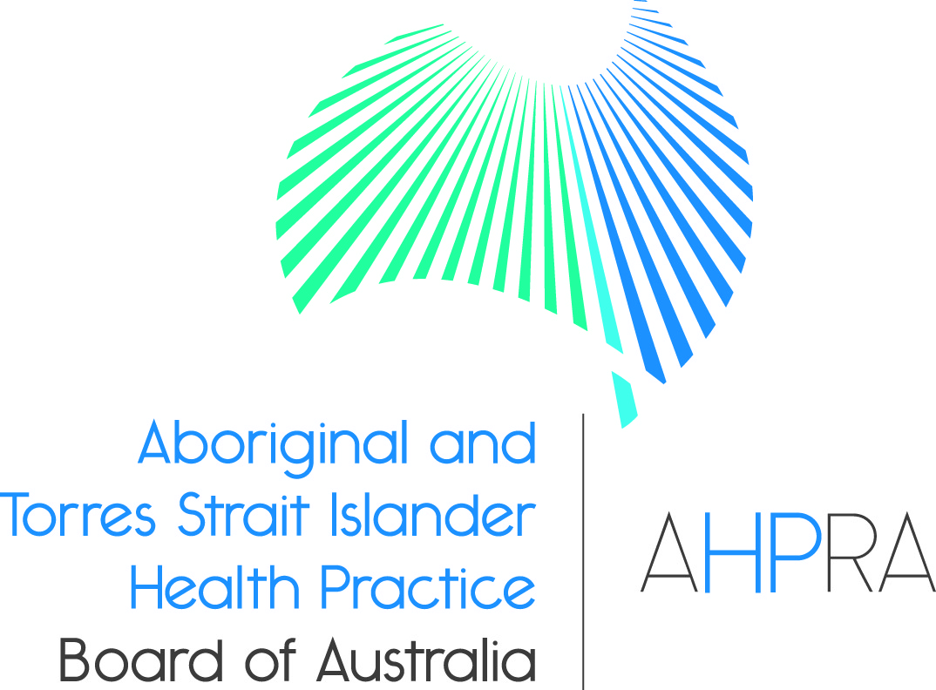

Aboriginal and Torres Strait Islander Health Practice Registrant Data: September 2014

Published November 2014

Introduction

The functions of the Aboriginal and Torres Strait Islander Health Practice Board of Australia include:
- registering the Aboriginal and Torres Strait Health Islander health practitioners and students
- developing standards, codes and guidelines for the Aboriginal and Torres Strait Islander health practice profession
- handling notifications, complaints, investigations and disciplinary hearings
approving accreditation standards and accredited courses of study.
The Board’s functions are supported by the Australian Health Practitioner Regulation Agency (AHPRA). For information about legislation governing our operations see AHPRA's Legislation & Publications at www.ahpra.gov.au/Legislation-and-Publications.aspx
The Board has analysed its registration data and produced a number of statistical breakdowns about registrants to share with the profession and community. The Board shares these breakdowns regularly.
For more information on Aboriginal and Torres Strait Islander Health Practitioners registration, please see the Board’s website: www.atsihealthpracticeboard.gov.au/Registration.aspx

Table of contents

ATSI health practitioners – registration type by state or territory 3
ATSI health practitioners – percentage by principal place of practice 3
ATSI health practitioners – registration type by age group 4
ATSI health practitioners – by age group 5
ATSI health practitioners – registration type by gender 6
ATSI health practitioners – percentage by gender 6

ATSI health practitioners – registration type by state or territory

ATSI health practitioners | Principal place of practice
Registration type | ACT | NSW | NT | QLD | SA | TAS | VIC | WA | No PPP | Total
General | 3 | 40 | 225 | 39 | 15 | 1 | 9 | 24 |  | 356
Non-practising
Total | 3 | 40 | 225 | 39 | 15 | 1 | 9 | 24 |  | 356

ATSI health practitioners – percentage by principal place of practice

ATSI health practitioners – registration type by age group
ATSI health practitioner | Registration type
Age group | General | Non-practising | Total
U - 25 | 7 |  | 7
25 - 29 | 22 |  | 22
30 - 34 | 33 |  | 33
35 - 39 | 43 |  | 43
40 - 44 | 67 |  | 67
45 - 49 | 58 |  | 58
50 - 54 | 53 |  | 53
55 - 59 | 39 |  | 39
60 - 64 | 24 |  | 24
65 - 69 | 7 |  | 7
70 - 74 | 2 |  | 2
75 - 79 | 1 |  | 1
80+
Total | 356 |  | 356

ATSI health practitioners – by age group

Age group | U - 25 | 25 - 29 | 30 - 34 | 35 - 39 | 40 - 44 | 45 - 49 | 50 - 54 | 55 - 59 | 60 - 64 | 65 - 69 | 70 - 74 | 75 - 79 | 80+
Count of registrants | 7 | 22 | 33 | 43 | 67 | 58 | 53 | 39 | 24 | 7 | 2 | 1

ATSI health practitioners – registration type by gender

ATSI health practitioner |  |  | Principal place pf practice
Gender | Registration type |  | ACT | NSW | NT | QLD | SA | TAS | VIC | WA | No PPP | Total
Female | General |  | 2 | 29 | 161 | 29 | 13 | 1 | 8 | 20 |  | 263
 | Non-practising
Sub Total |  |  | 2 | 29 | 161 | 29 | 13 | 1 | 8 | 20 |  | 263
Male | General |  | 1 | 11 | 64 | 10 | 2 |  | 1 | 4 |  | 93
 | Non-practising
Sub Total |  |  | 1 | 11 | 64 | 10 | 2 |  | 1 | 4 |  | 93
Total |  |  | 3 | 40 | 225 | 39 | 15 | 1 | 9 | 24 |  | 356

ATSI health practitioners – percentage by gender

ATSI health practitioner | Principal place of practice
Gender | ACT | NSW | NT | QLD | SA | TAS | VIC | WA | Total
Female | 66.67% | 72.50% | 71.56% | 74.36% | 86.67% | 100.00% | 88.89% | 83.33% | 73.88%
Male | 33.33% | 27.50% | 28.44% | 25.64% | 13.33% | 0.00% | 11.11% | 16.67% | 26.12%

